Cellular Respiration and Effects of Pollutants on its Rate
(Draft)

Student’s Name: Zhengyi Zhou
Crouse: EVPP-110-001
Instructor: Mangukiya, Rupal
Date: 03/21/2019

Abstract
This experiment is carried out mainly to research and understand on cellular and how to make respiration movement in our life. And research on different type of pollution was determined regardless to how it affects the respiration rate of cellular. Initially, the idea was to examine if certainly pollutants disposed on to the environment affects the life of organisms by disrupting their habitants onto their capabilities to carry out their cellular respiration. The research was majorly to check how cellular respiration added on yeast and the quantity of gas emitted to estimate amount of carbon dioxide released as yeast carries out cellular respiration and how it affect the workability of small creatures. The first experiment is to determine the effects of carbohydrates on cellular respiration and this can be done by addition of sugar solution onto the yeast in one test tube and addition of water and yeast on another test tube. This experiment is done to determine the amount of carbon dioxide that is needed to increase the late of cellular respiration. The second experiment is to determine on how various pollutant such as isopropyl alcohol, vinegar, salt solution, soap solution, or baking soda solution effect the rate of cellular respiration. Yeast is added together with salt solution, and the amount of gas given for duration of about 10 minutes is estimated in order to determine the rate of cellular respiration.

Introduction
Cellular respiration is an essential part in our life, because we all need energy to function and we get this energy from the food and water, the most efficient way for cells to harvest energy stored in food is through cellular respiration (Regina Bailey, 2016). As the same time, there are a lot of factors that affect cellular respiration, such as temperature, concentration of carbon dioxide and pollutants (Iris Hernández, 2017). Through this experiment, we manly consider two parts that affect the rate of cellular respiration, namely, the effect of carbohydrate source and the effect of a pollutant.
Part A: Find out how carbohydrate effect of cellular respiration. We need to establish a comparative experiment. Mix yeast, water with and without sugar. Here sugar is used as a carbohydrate in the experiment. As a result, the null hypotheses on the yeast without the source of sugar will produce less carbon dioxide gas which means that it has lower rate of cellular respiration than yeast with source of sugar.
Part B: We also consider how the pollutant effect of cellular respiration. We choose six different substances as pollutants. They are Isopropyl alcohol, Vinegar, salt solution and others. The null hypothesis is that the yeast will have a lower rate of cellular respiration mixed the source of pollutant than that without the source of pollutant.
During this experiment, we measure the volume produced by carbon dioxide to determine the rate of cellular respiration. The yeast like us, need to get food from the environment in order to grow and to reproduce. In the experiment, the sugar is used as a source of food to provide energy. As a result, carbon dioxide gas is produced. This process is mainly known as cellular respiration. When we mix pollutant into the yeast and sugar, the pollutant reduces the amount of carbon dioxide gas. That is because the pollutant gets into the water leading to the contamination of water sources. This makes yeast not to access enough water as the pollutant also destroys the structure of yeast and sugar making it to produce less carbon dioxide gas.
Method
Part A: We need to prepare two 25ml beaker, 2 gas measuring pot, warm water, spoon measuring, yeast, sugar. Experiment number 1: yeast with water only, experiment number 2: yeast, water with sugar. Measure 1.25 ml of yeast and place it into both beaker #1 and beaker #2. Measure 1.25ml of sugar and place into beaker #2, and thoroughly mix sugar and yeast. Measure and add to each beaker 13ml warm water, not hot or tap water. Stir it fully to make mix properly. Separate the mixture and place it into the gas measuring pot #1 and gas measuring pot #2. Observe the gas measuring pots reticle and record the volume of gas produced each in minute for a period of 10 minutes. As the result are shown in the table 6.1.
Part B: Mix each pollutant (isopropyl alcohol, vinegar, 10% salt solution, 5%, baking soda solution, 1% bleach solution, or 10% soap solution.) with yeast, sugar and warm water into separate gas measuring pot. Observe the gas measuring pots reticle and record the volume of gas produced in each minute for a period of 10 minutes as the results are shown in the table 6.2.

Result
The table 6.1 Gas (CO2) volume (mL) at 1-minute intervals for 10 minutes for culture tube containing yeast and water versus culture tube containing yeast, water, and sugar.

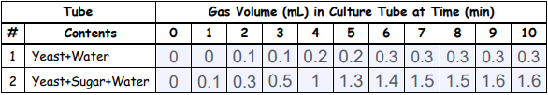
Table 6.1
The table 6.2 Gas (CO2) volume (mL) at 1-minute intervals for 10 minutes for 6 culture tubes, each containing yeast, water, sugar, and one of six simulated pollutants.
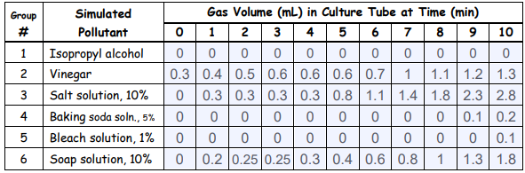
Table 6.2

The table 6.3 Total volume of CO2 produced and cellular respiration rate (mL/min) for 8 combinations of yeast, water, sugar, and simulated pollutant.
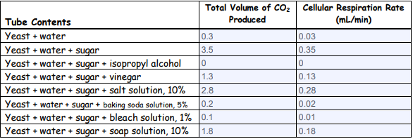
Table 6.3

Discussion
In this experiment, we mainly study sugar and other pollutants effect of cellular respiration. According to table 6., we can conclude that sugar can be used as food in the experiment and promotes the production of more carbon dioxide. The null hypotheses on yeast without the source of sugar will produce less carbon dioxide gas which means that there is lower rate of cellular respiration than yeast with source of sugar. According to tables 6.2 and table 6.3, different pollutants will have different inhibition of carbon dioxide production. The null hypotheses yeast with water only will produce less carbon dioxide gas which means that there is lower rate of cellular respiration. The null hypothesis on yeast with water and sugar will produce more carbon dioxide gas which means that there is higher rate of respiration. The null hypothesis on yeast with water, sugar and pollutant solution will produce less carbon dioxide gas which means that there is lower rate of cellular respiration. This simply states that lack of carbohydrate leads to a lower cellular respiration than a source with carbohydrate. Also, there is indication that the pollutant used were all harmful and that why low rate of cellular respiration were recorded.

References
Largen, K., B., Environmental science lab manual and notebook volume 1: The science
Bailey, R (2017) Cellular Respiration Quiz. ThoughtCo. Retrieved from: https://www.thoughtco.com/cellular-respiration-quiz-373395
Walsh, J., & Wuebbles, D. (2014) Climate Change Impacts in the United States. Alaska, Fairbanks: University of Alaska Fairbanks
Hernández, I (2017) What are factors that affect cellular respiration?. Quora. Retrieved from: https://www.quora.com/What-are-factors-that-affect-cellular-respiration

